ITA0305- Mobile Computing
LAB EXPERIMENT
Name: G.Ganesh
Reg NO:192373008

10. Create a visual representation in Figma showcasing the differences between various multiple access techniques.

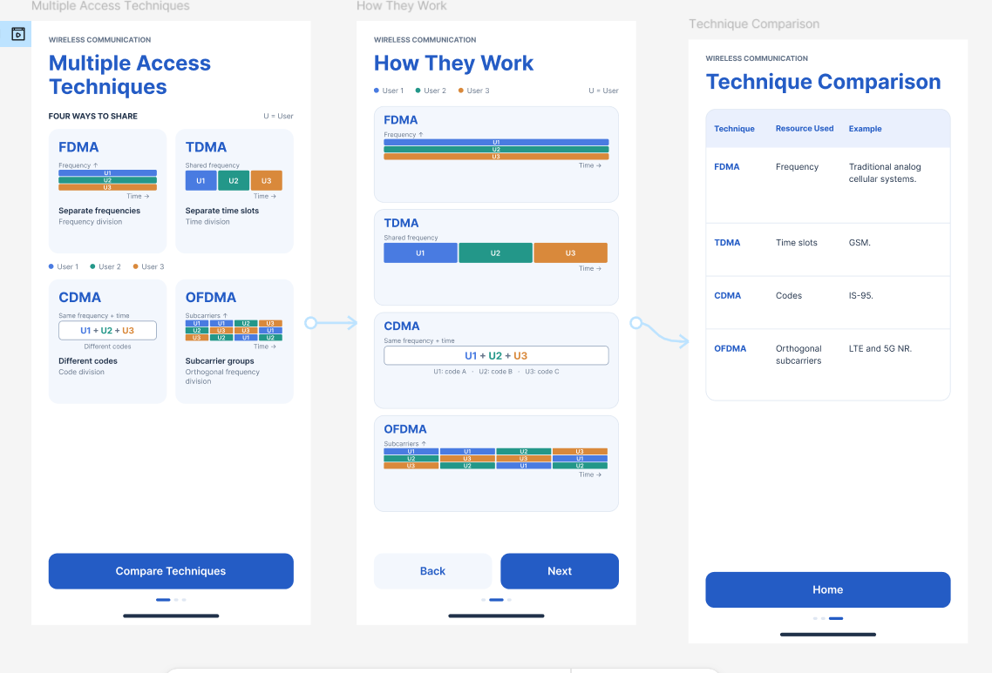
https://www.figma.com/design/IfgkRzSTMFf22AItybqLOi/program10?node-id=0-1&p=f&t=7V8NXOJ1ecOAWj2u-0

